Tenniel Takenaka-Fuller

CPE301 – SPRING 2018

Design Assignment 4

**DO NOT REMOVE THIS PAGE DURING SUBMISSION:**

The student understands that all required components should be submitted in complete for grading of this assignment.

|  |  |  |  |
| --- | --- | --- | --- |
| **NO** | **SUBMISSION ITEM** | **COMPLETED (Y/N)** | **MARKS**  **(/MAX)** |
| 1 | COMPONENTS LIST AND CONNECTION BLOCK DIAGRAM w/ PINS |  |  |
| 2. | INITIAL CODE OF TASK 1/A |  |  |
| 3. | INCREMENTAL / DIFFERENTIAL CODE OF TASK 2/B |  |  |
| 3. | INCREMENTAL / DIFFERENTIAL CODE OF TASK 3/C |  |  |
| 3. | INCREMENTAL / DIFFERENTIAL CODE OF TASK 4/D |  |  |
| 3. | INCREMENTAL / DIFFERENTIAL CODE OF TASK 5/E |  |  |
| 4. | SCHEMATICS |  |  |
| 5. | SCREENSHOTS OF EACH TASK OUTPUT |  |  |
| 5. | SCREENSHOT OF EACH DEMO |  |  |
| 6. | VIDEO LINKS OF EACH DEMO |  |  |
| 7. | GOOGLECODE LINK OF THE DA |  |  |
|  |  |  |  |
|  |  |  |  |

1. **COMPONENTS LIST AND CONNECTION BLOCK DIAGRAM w/ PINS**

The components used are ATMEGA 328p, servo motor, dc motor, stepper motor, L293D, potentiometer, and switch button.

1. 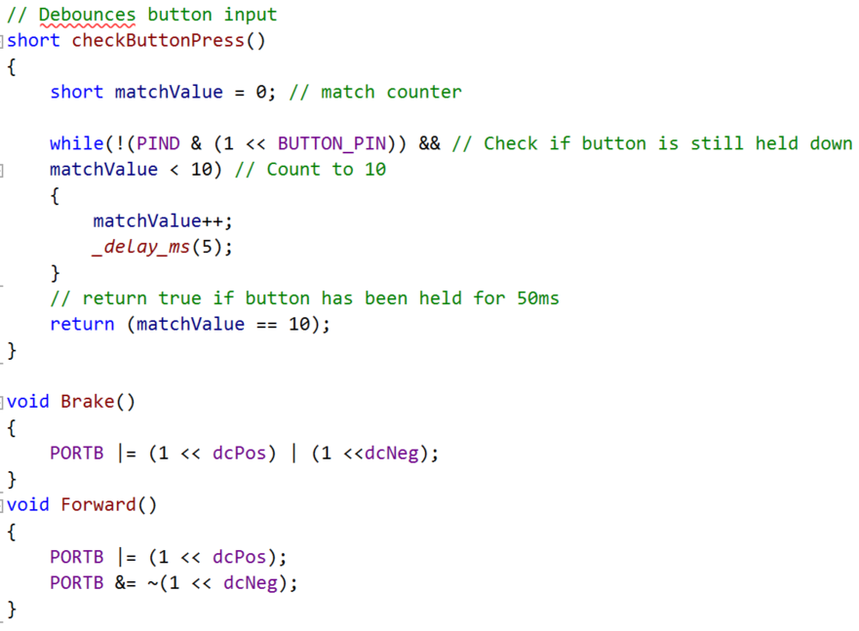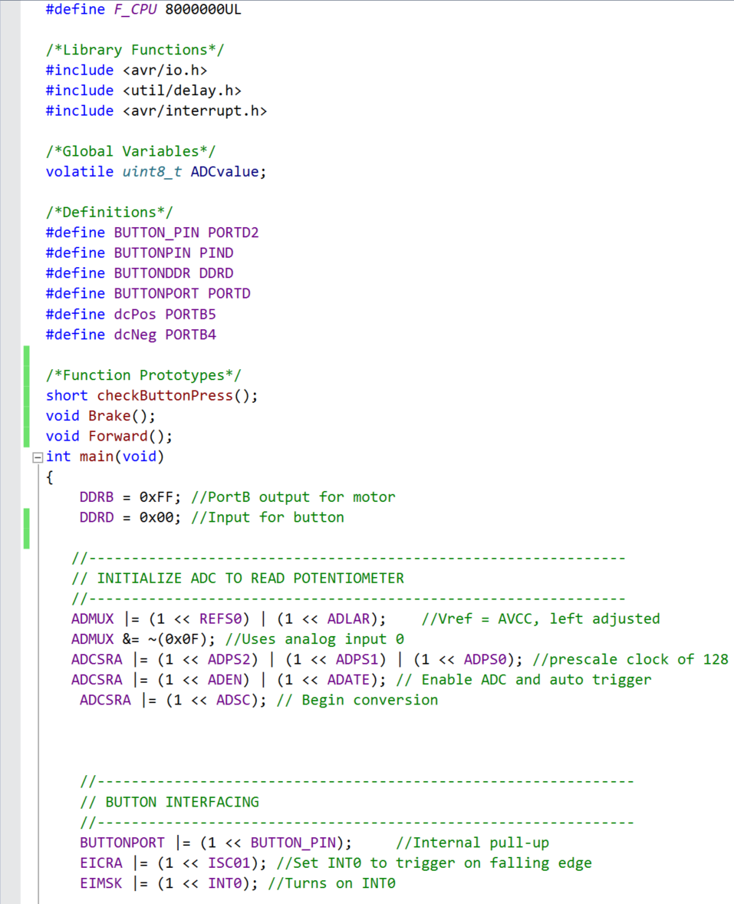**Task 1**

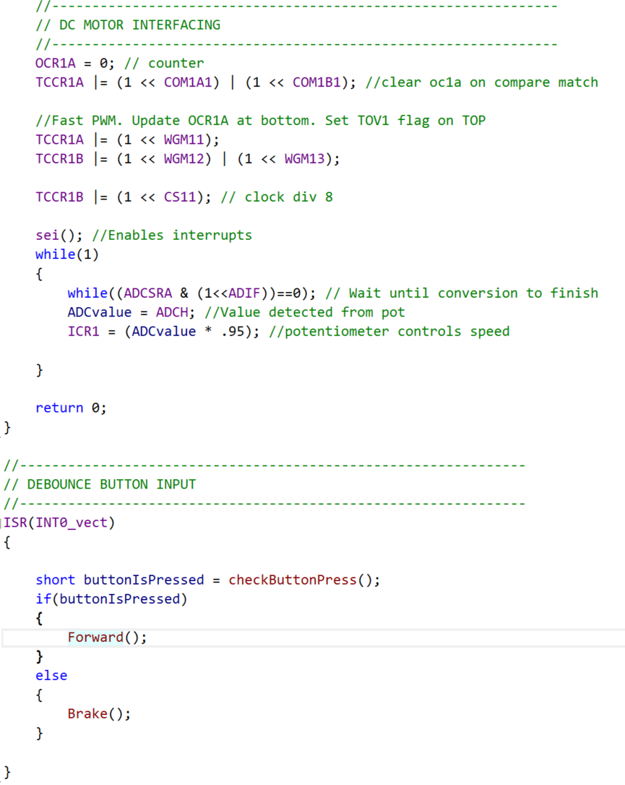

1. **Task 2**

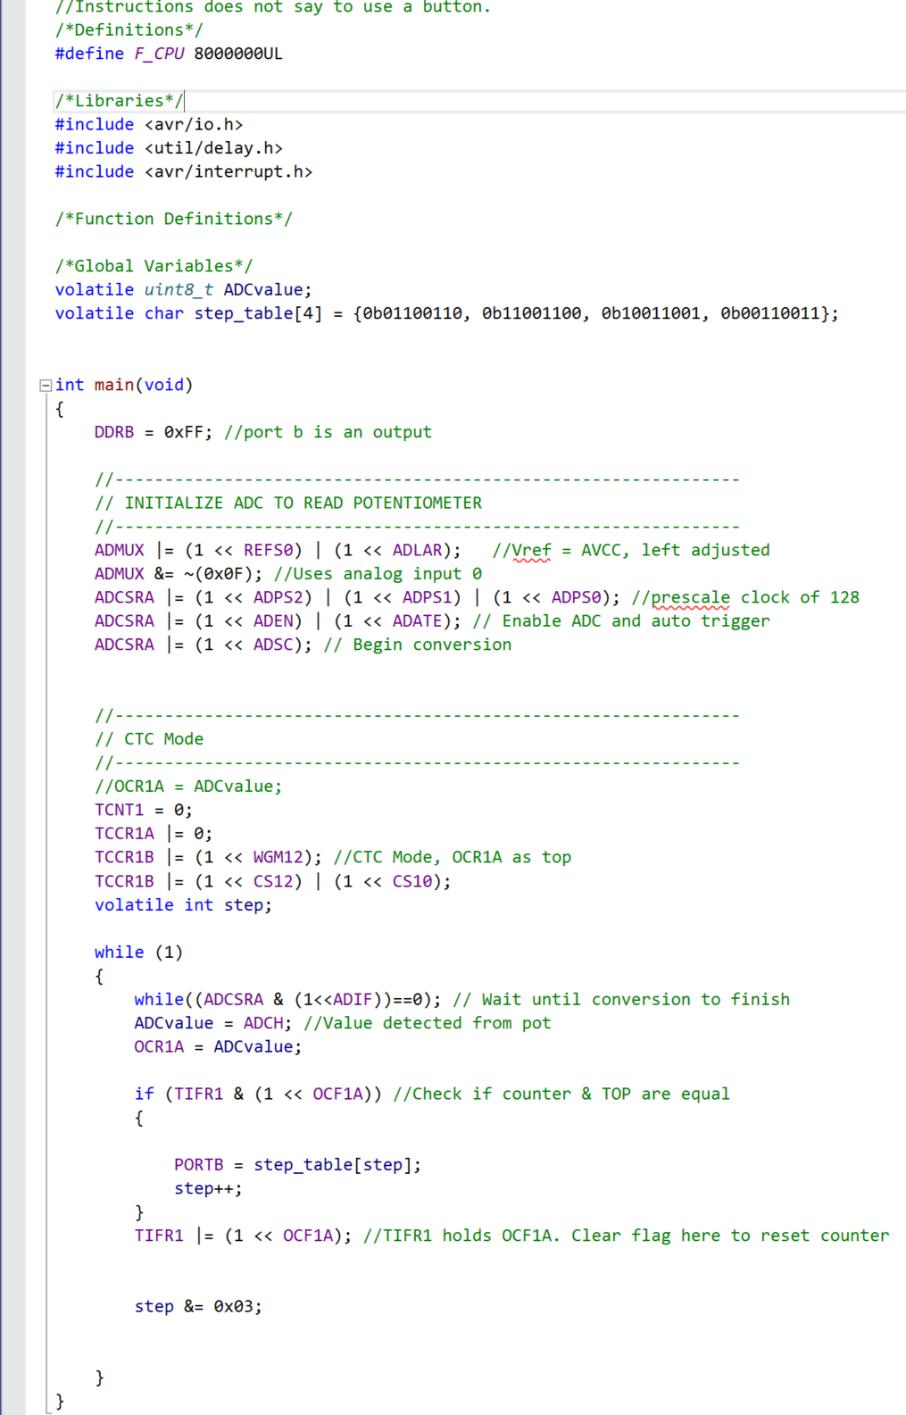

1. **Task 3**

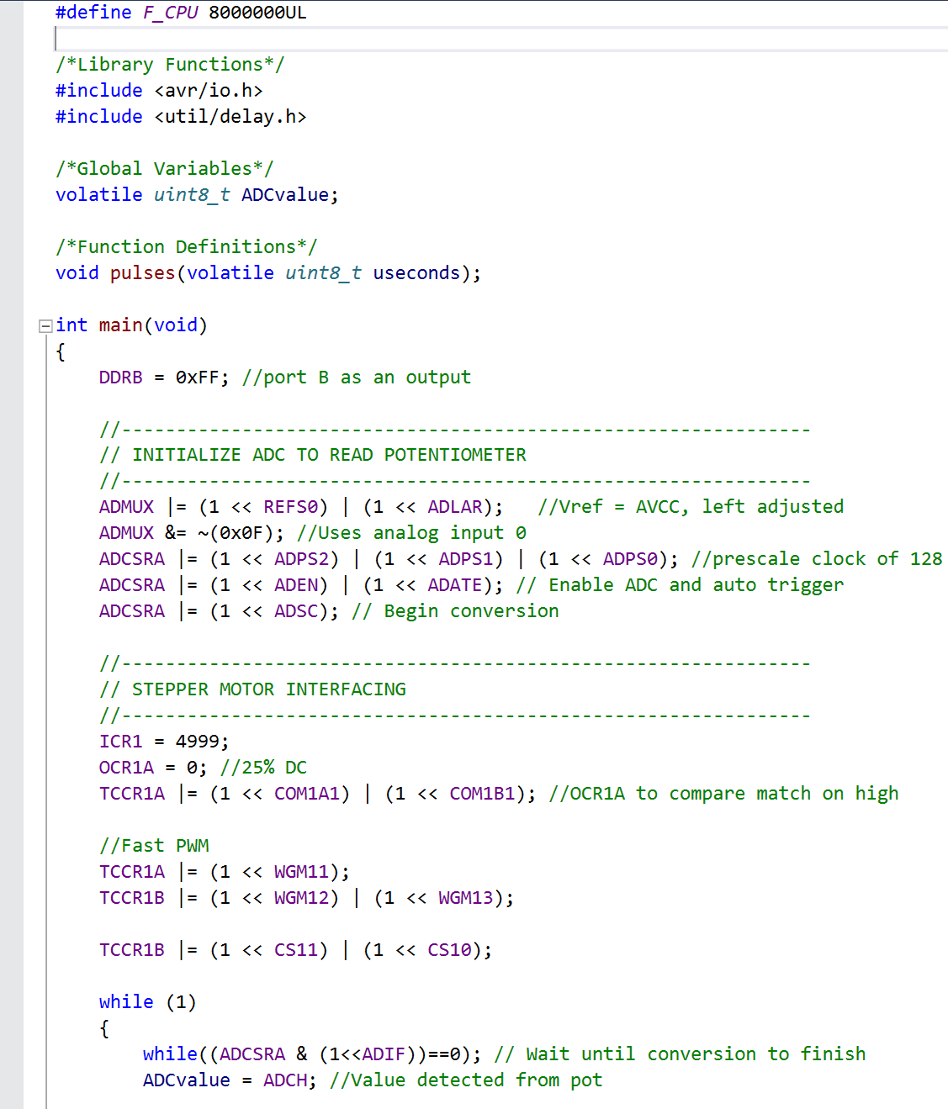

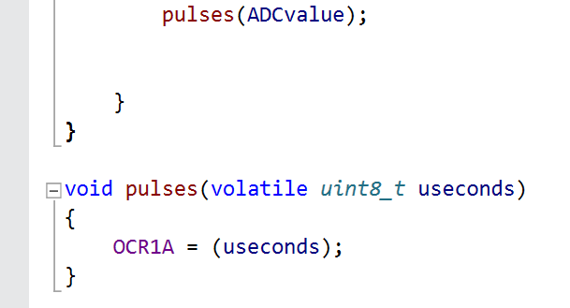

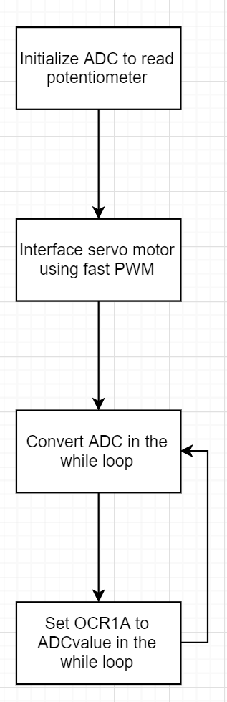

1. **SCHEMATICS & FLOW CHART**

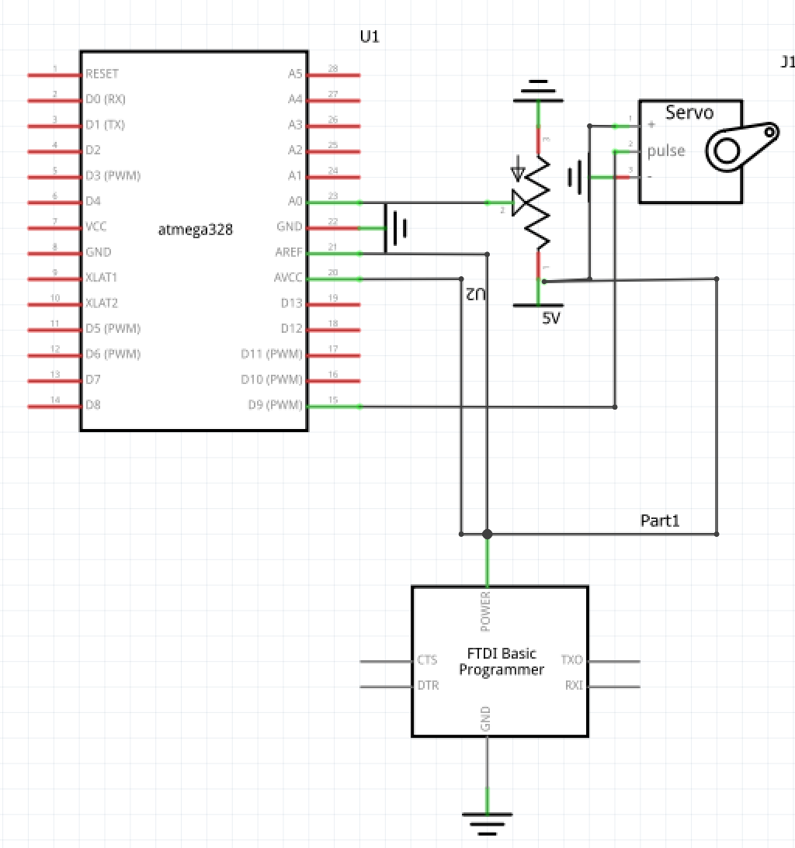

**Task 3 schematic and flow chart**

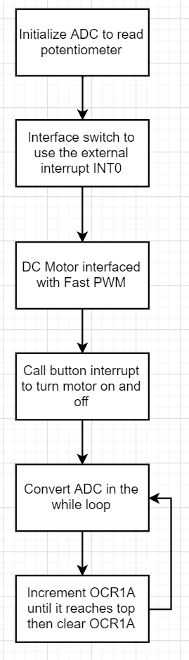**Task 1 schematic and flow chart**

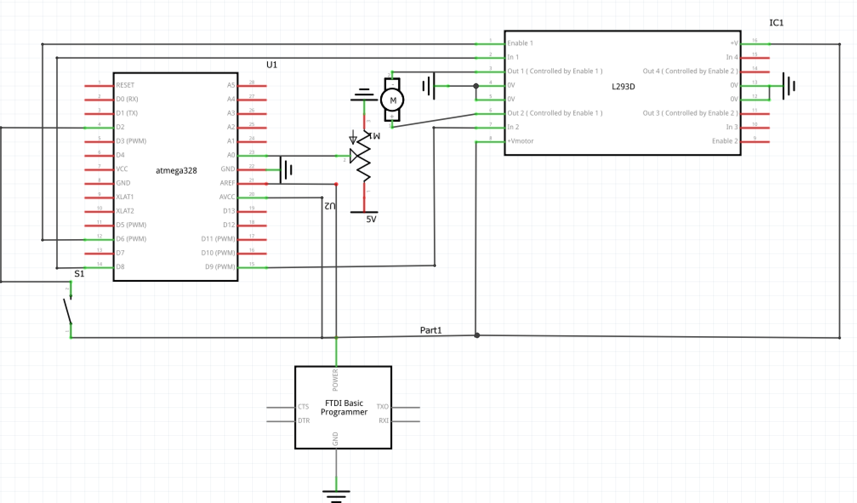

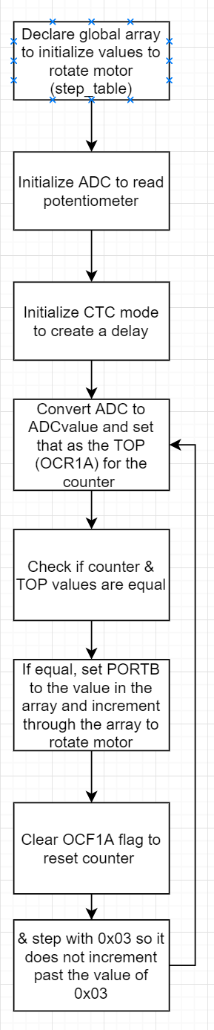**Task 2 Schematic & Flow Chart**

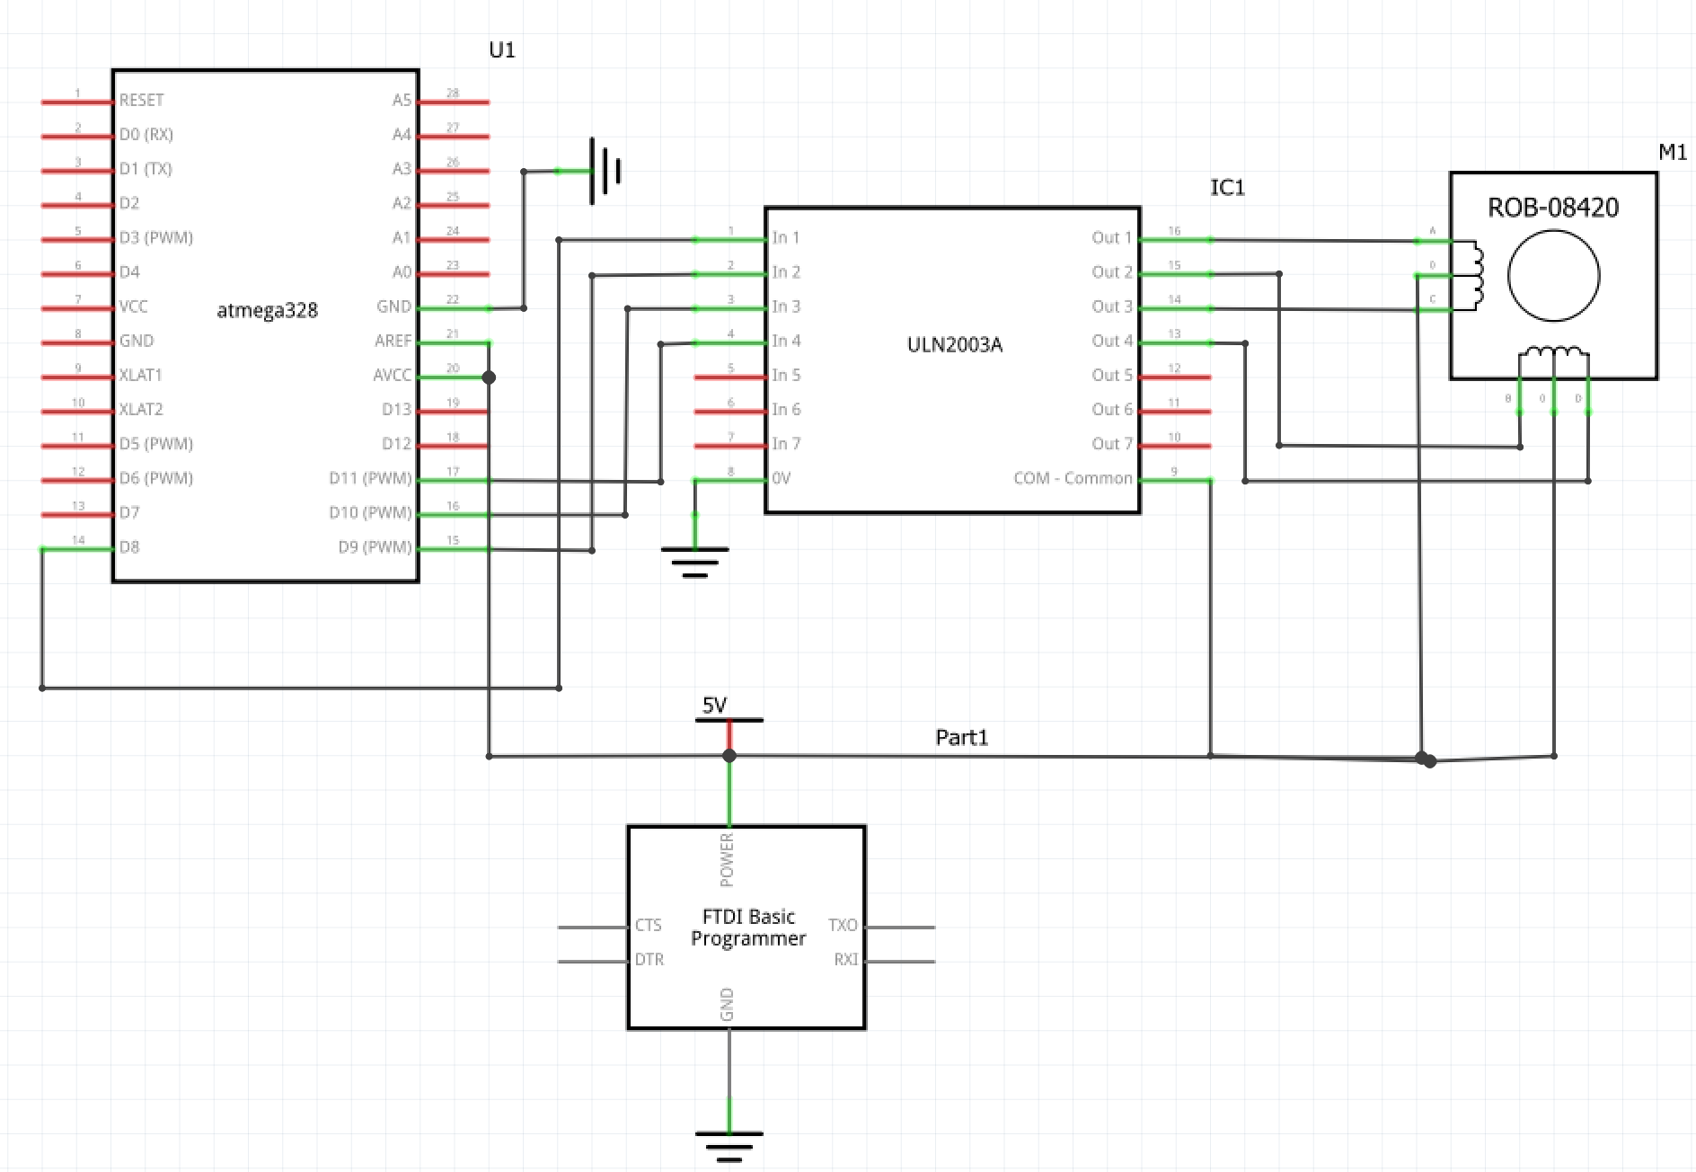

1. **SCREENSHOT OF EACH DEMO (BOARD SETUP)**

**Task 1**

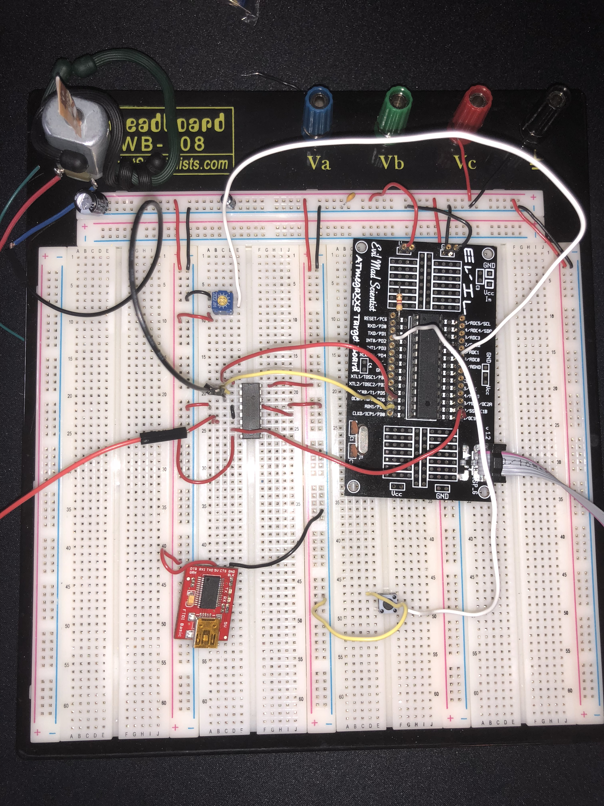

**Task 2**

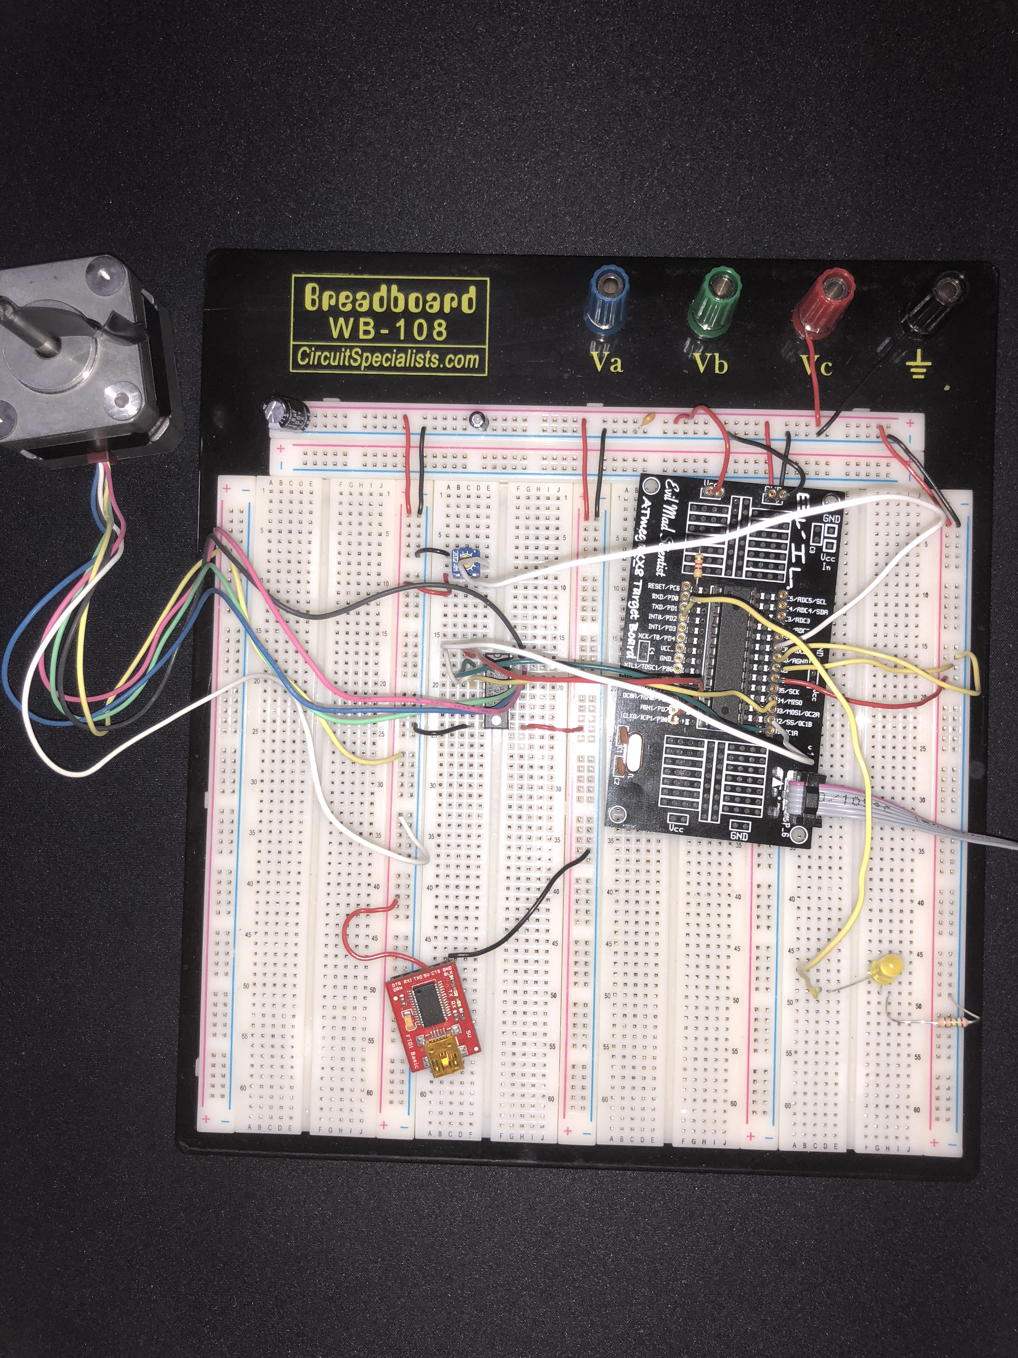

**Task 3**

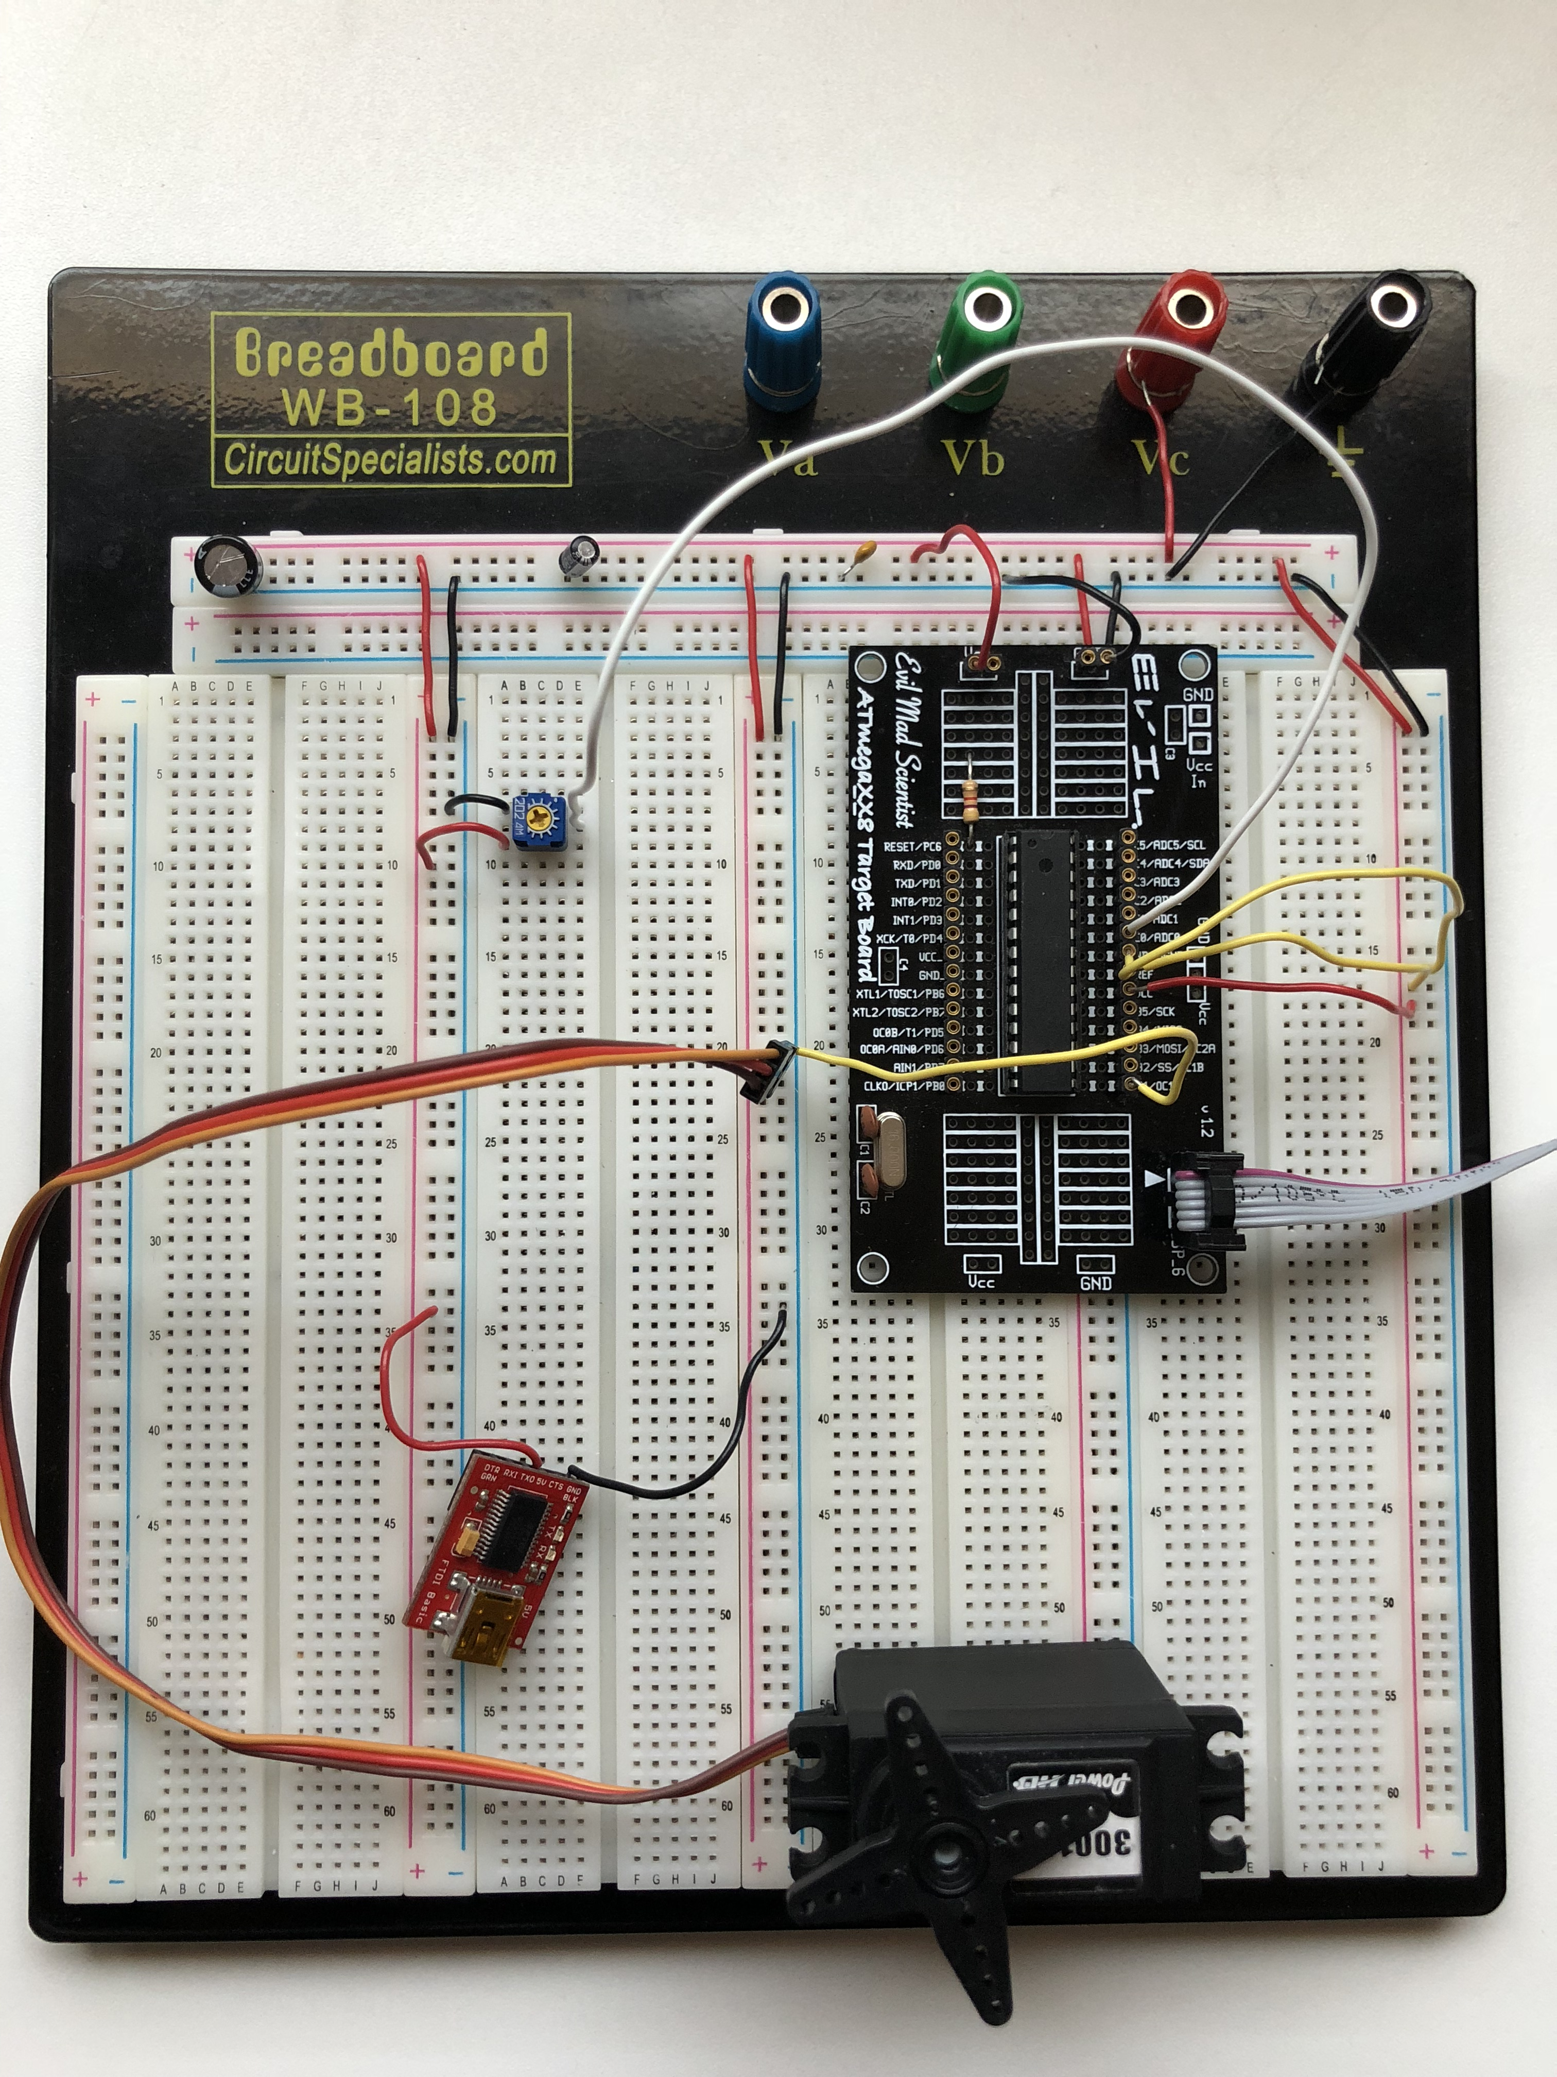

1. **VIDEO LINKS OF EACH DEMO**

<https://youtu.be/yd44scJtIr4>

1. **GITHUB LINK OF THIS DA**

**The professor allowed me to turn in my assignment Monday 4/16 due to my DC motor breaking over the weekend.**

https://github.com/TennielTakenaka/DA4

**Student Academic Misconduct Policy**

<http://studentconduct.unlv.edu/misconduct/policy.html>

“This assignment submission is my own, original work”.

NAME OF THE STUDENT